MINI PROJECT ON INTRUDER ALARM CIRCUIT

The circuit diagram of an ultra sensitive intruder alarm is shown below. The darkness of an burglar moving past few measures close by the routine is enough to induce the security.

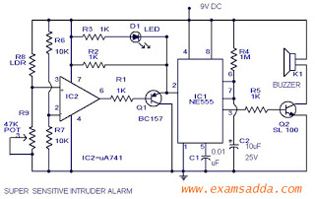

Here IC2 uA 741 is wired as a delicate comparator ,whose set factor is set by R6 &R7. The current split by LDR and R9 is given at non inverting pin of IC2. At stand by function these two currents are set equivalent by changing R9. Now the result (pin6) of comparator will be great.Transistor Q1 will be off. The current at induce pin of IC1 will be good and there will be no security. When there is an burglar near the LDR the darkness causes its level of capacity improve. Now the currents at the information of comparator will be different and the out put of IC2 will be low. This creates Q1 on. This creates a bad going beat to induce the IC1 which is wired as a monostable multivibrator.The out put of IC1 will be increased by Q2 (SL 100) to generate security.

Note:

To setup the alarm ,power up the circuit and adjust R9 so that LED D1 goes off.

The LDR can be housed in a dark tube to increase sensitivity.

The sensitivity is very important here. If you cannot adjust the required sensitivity properly, use one LOW resistance (~1K ) POT in series with R9 for fine adjustment.